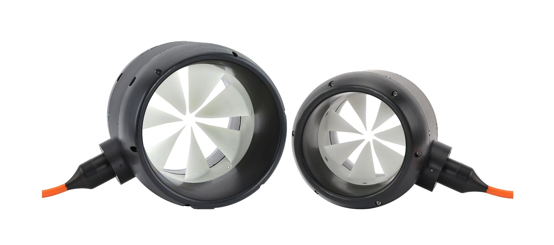
Table of Contents
1.0 Introduction 3
1.1 Vehicle Overview 4
1.1.1 Type of vehicle 4
1.1.2 Type of Operation/Functionality of Vehicle 4
1.1.3 Single or Series 5
1.1.4 Vehicle Power Specifications 5
1.1.5 Hardware Setup/Wiring Diagram 5
2.0 Target Thruster Specifications 6
3.0 Extras and Spare Parts 7
4.0 Compliances 7
5.0 Acoustic Sound Level of Thruster 8
6.0 Contact Info 8

Introduction
The purpose of this document is to specify the propulsion solution delivered by Copenhagen Subsea A/S (CS)
Document Information
Created by: |  |  | CTY |  | Version: |  |  | 1.4
Edited by: |  |  | CTY |  | Last date of change: |  |  | 2023-01-10
Version Record
Version No. |  |  |  | Changes |  | Date of Change |  | Changed By
Customer Information
Company Name: |  |  |  |  | Address:
Country: |  |  |  |  | State:
City: |  |  |  |  | Zip Code:
Phone: |  |  |  |  | Customer Registration Number/TAX number
Contact Person Information
First Name: |  |  |  |  | Last Name:
Title:
Work Phone: |  |  |  |  | Direct Mobile:
E-mail: |  |  |  |  | Ext.

1.1 Vehicle Overview
Please complete the sections underneath thoroughly – thank you.

1.1.1 Type of vehicle
Describe the type of vehicle (ROV, AUV etc.) - please insert a drawing or image of the vehicle.
Click Here to Enter Text or Image

1.1.2 Type of Operation/Functionality of Vehicle
Describe or visualize the purpose and functionality of the vehicle.
Click Here to Enter Text or Image

1.1.3 Single or Series
Select whether you intend to build a single vehicle or produce a series of vehicles.
☐ Single Vehicle ☐ Series of Vehicles
If series, select the number of vehicles you intend to produce Select Quantity

1.1.4 Vehicle Power Specifications
Please fill out the table below.
Vehicle Power Specifications
Minimal Supply Voltage (VDC) | Enter Minimal Supply Voltage
Nominal Supply Voltage (VDC) | Enter Norminal Supply Voltage
Maximal Supply Voltage (VDC) | Enter Maximal Supply Voltage
Current Limitation (A) per Thruster | Enter Current Limitation
Available Power per Thruster (kW) | Enter Available Power per Thrsuter

1.1.5 Hardware Setup/Wiring Diagram
Insert wiring diagram below

Target Thruster Specifications
Fill out a table for each wanted size and configuration.

Thruster Specifications
Thruster Version: (Size) | Select Version
Thruster Configuration | Select Configuration
Quantity of Thruster(s) | Select Quantity
Select Quantity of Spare Thruster(s) | Select Quantity
Functionality of Thruster | Describe the intended functionality of the Thruster(s)
Mounting of Thruster | Selection of Mounting
Required Thrust Force (Newton or kgf) | Enter Required Thrust Force
Depth Range (m) | Select Depth Rating
Length of Cable per Thruster (m) fixed by CS | 1 meter
Max. Temperature of Operational Seawater | Enter max. seawater temperature

Thruster Specifications
Thruster Version: (Size) | Select Version
Thruster Configuration | Select Configuration
Quantity of Thruster(s) | Select Quantity
Select Quantity of Spare Thruster(s) | Select Quantity
Functionality of Thruster | Describe the intended functionality of the Thruster(s)
Mounting of Thruster | Selection of Mounting
Required Thrust Force (Newton or kgf) | Enter Required Thrust Force
Depth Range (m) | Select Depth Rating
Length of Cable per Thruster (m) | Enter Length of Cable per Thruster
Water-cooled cable | Select Option
Max. Temperature of Operational Seawater | Enter max. seawater temperature

3.0 Extras and Spare Parts
Fill out the table below if extras or spare parts are wanted.
Extras and Spare Parts
Maintenance Tools | Select Size & Select Size & Select Size & Select Size | Select Tool
Propeller | Select Size & Select Configuration | Select Quantity
Propeller | Select Size & Select Configuration | Select Quantity
Propeller | Select Size & Select Configuration | Select Quantity
Propeller | Select Size & Select Configuration | Select Quantity
Inlet Ring | Select Size | Select Quantity
Inlet Ring | Select Size | Select Quantity
Inlet Ring | Select Size | Select Quantity
Inlet Ring | Select Size | Select Quantity
Outlet Ring | Select Size | Select Quantity
Outlet Ring | Select Size | Select Quantity
Outlet Ring | Select Size | Select Quantity
Outlet Ring | Select Size | Select Quantity
Independent Certified Pressure Verification | Select Option | If yes, Select Depth Rating

4.0 Compliances
All thruster from Copenhagen Subsea A/S is in conformity with the requirements and provisions of the following European Union directives and their respective standards. See table below.
Partly Completed Machinery Directive | 2006/42/EC
EMC Directive | EMC 2014/30/EU
RoHS Directive | RoHS 2077/65/EU
REACH Directive | (EC) No. 1907/2006
Harmonised Standards | EN 60945
 | EN 60204-1
 | EN 60335-1
DNV • GL – Rules for Classification | Underwater technology, Edition December 2015  Part 3 Pressure hull and structures  Chapter 2 Design loads

If additional compliances are required regarding the thruster(s) or motor controller, please state the required standards below.
Insert Additional Required Thruster Compliances

5.0 Acoustic Sound Level of Thruster
Acoustic Sound Level
Version | Max. SPL(dB)
Version Small (VS) | 145 SPL(dB)
Version Medium (VM) | 150 SPL(dB)
Version Large (VL) | 152 SPL(dB)
Version Extra Large (VXL) | 155 SPL(dB)

6.0 Contact Info
Copenhagen Subsea A/S
Troljevej 2 · DK-2900 Hellerup, Denmark
Tel: +45 70 22 11 62
E-mail: sales@copenhagensubsea.com

